CO-1 OUTPUT PREDICTION
NAME:K.Srinath Date:24-7-2026
Reg.no:192524220
Course code:CSA0307
Course name: DATA STRUCTURES

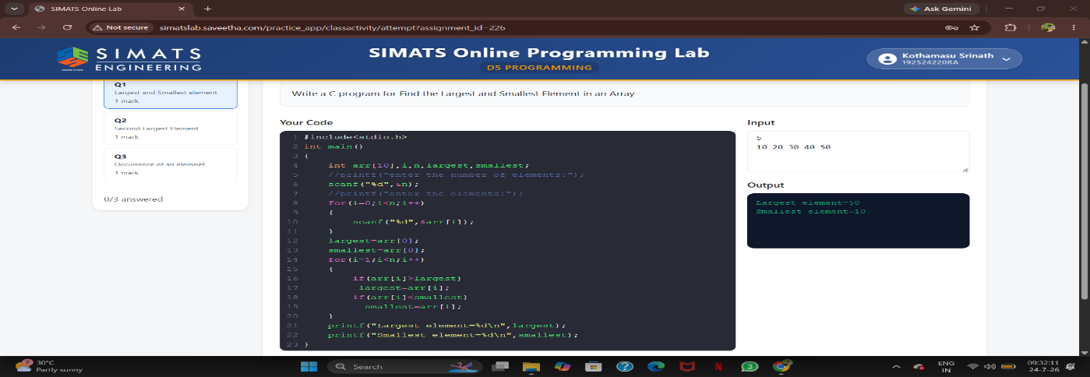
QUESTION-1:

QUESTION-2:
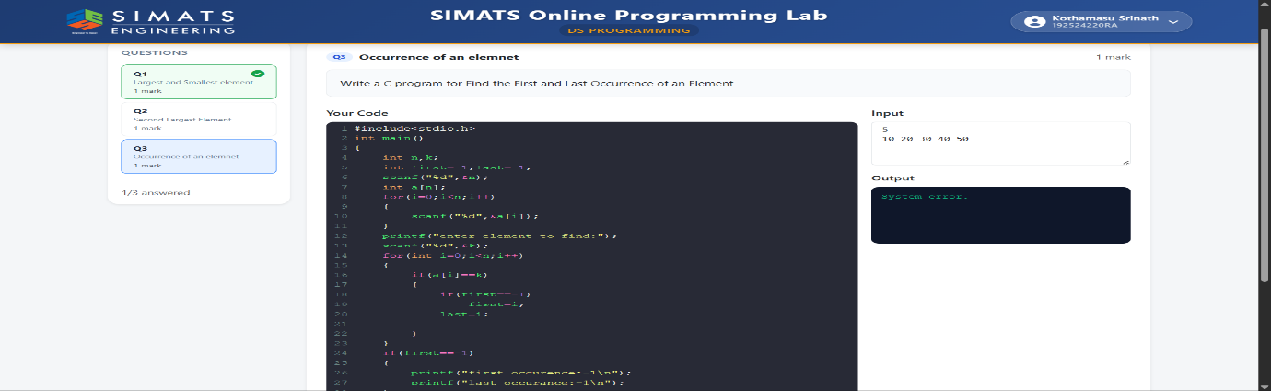

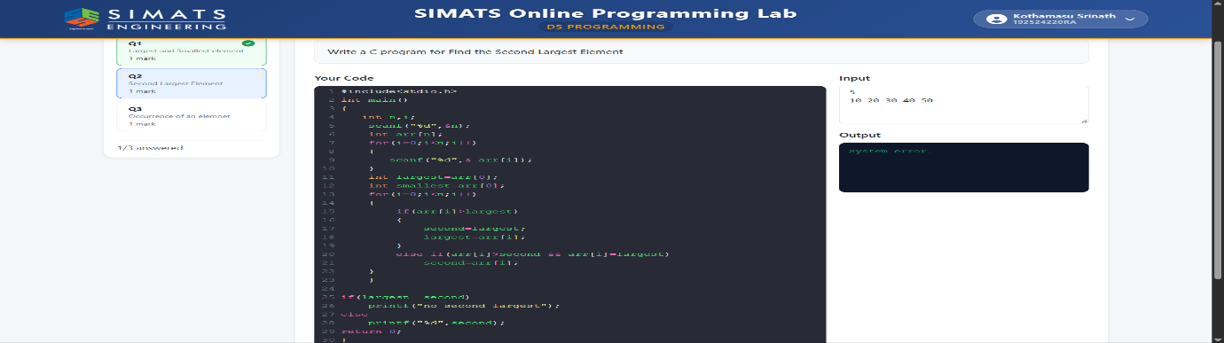
QUESTION-3:

